MYSQL DATA LOADING & CLEANING STEP BY STEP

- Open Your Workbench and Create a Database with name “jobs_db” and refresh the ‘Schemas’ to see whether you database is created or not.
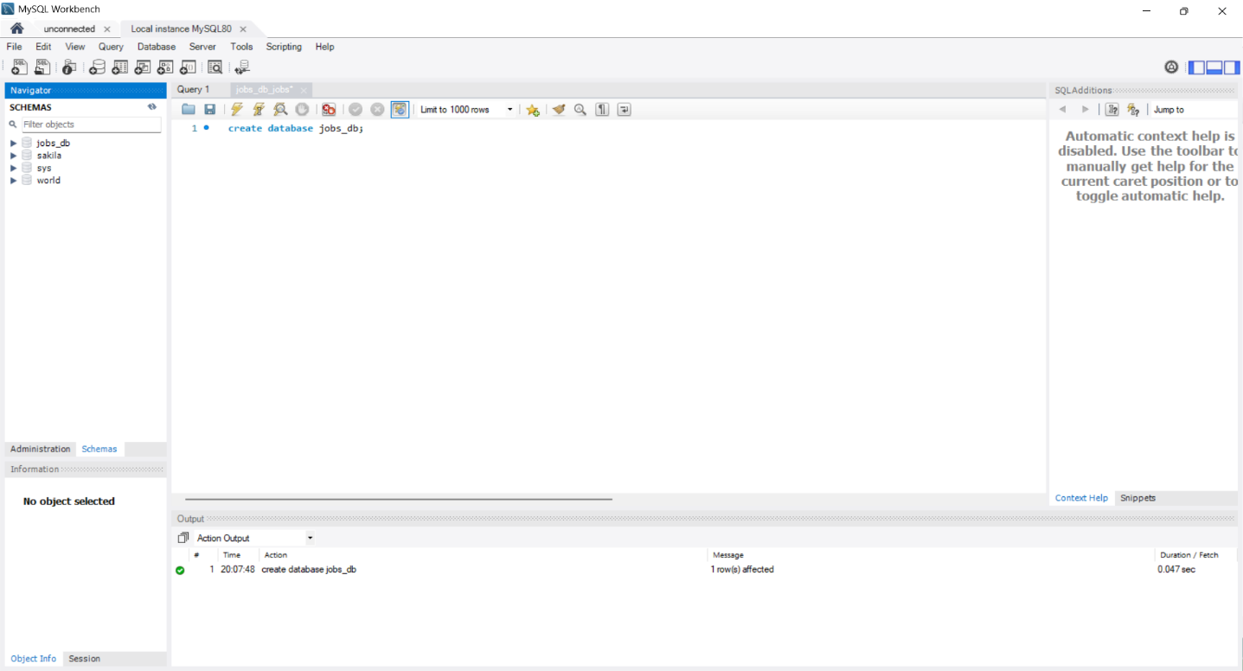

- To use the database use the query “use jobs_db” this will make your database active and ready to use. 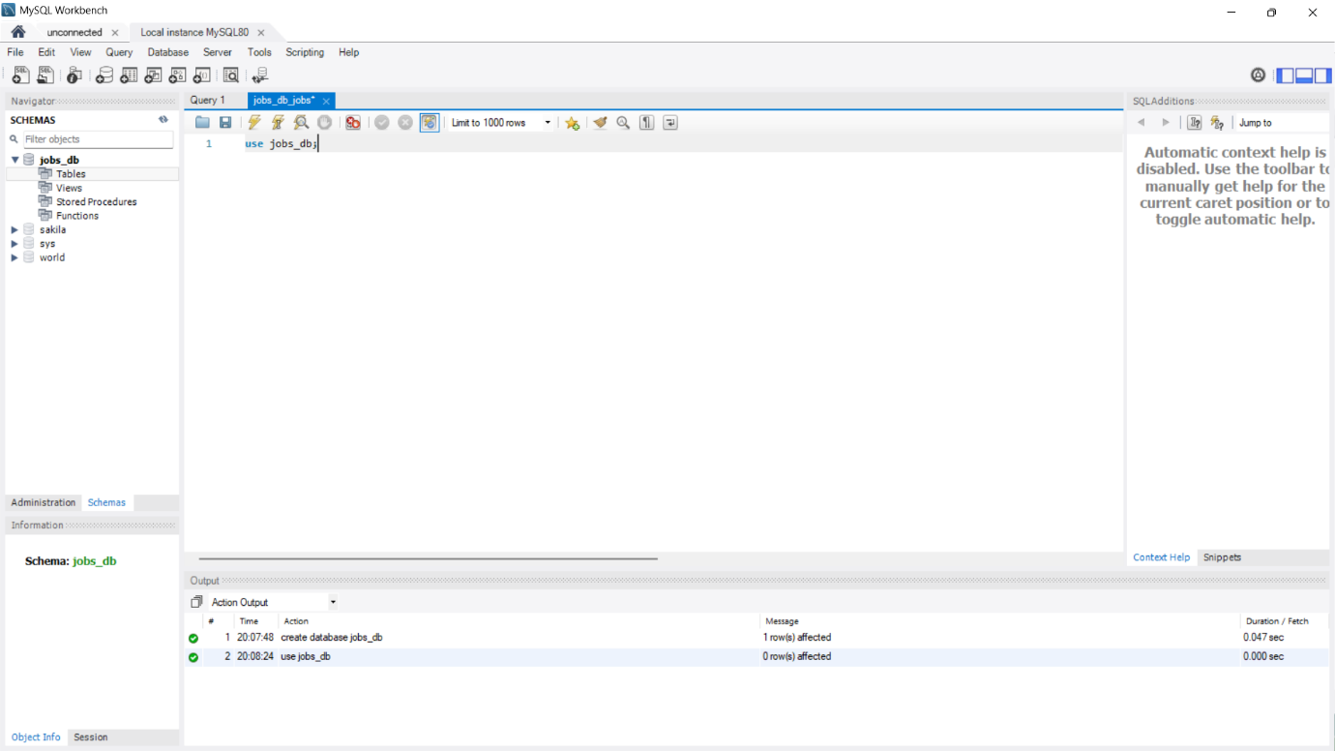

- Right click on the database and select the option ‘Table Data Import/ Wizard’ to import your Raw Data.
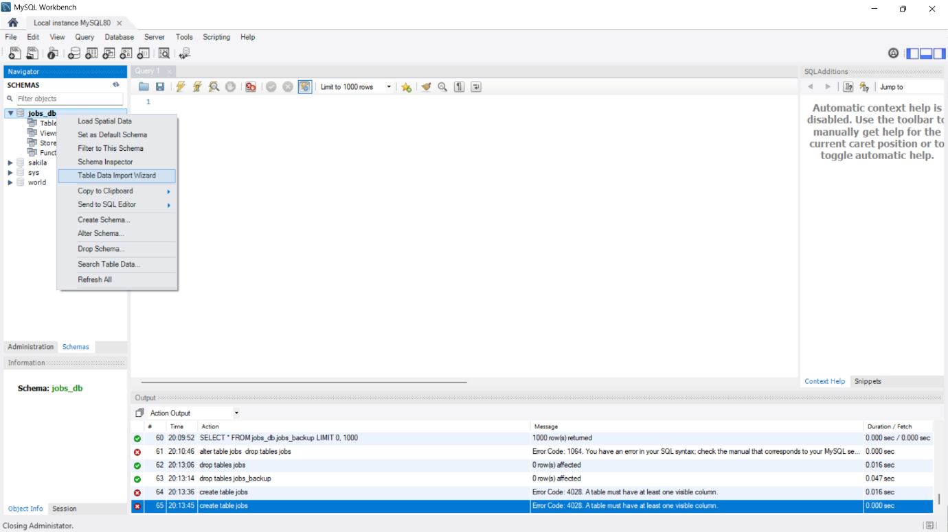

- Select the file path to import the data.
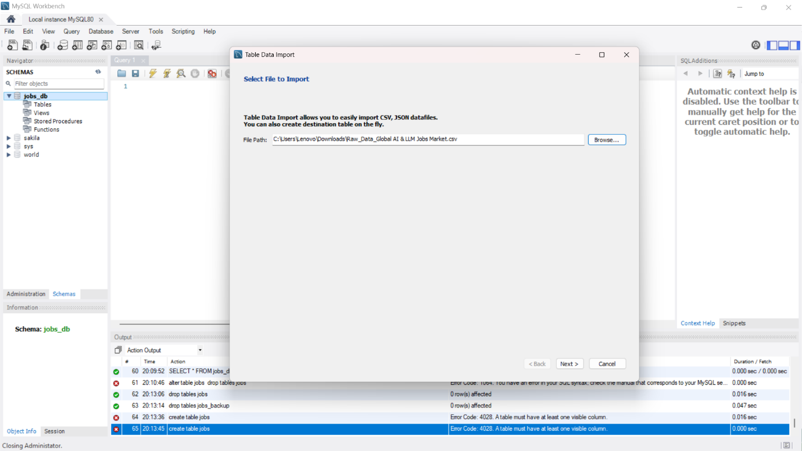

- Rename the Table like ‘jobs’ or anything as you wish.
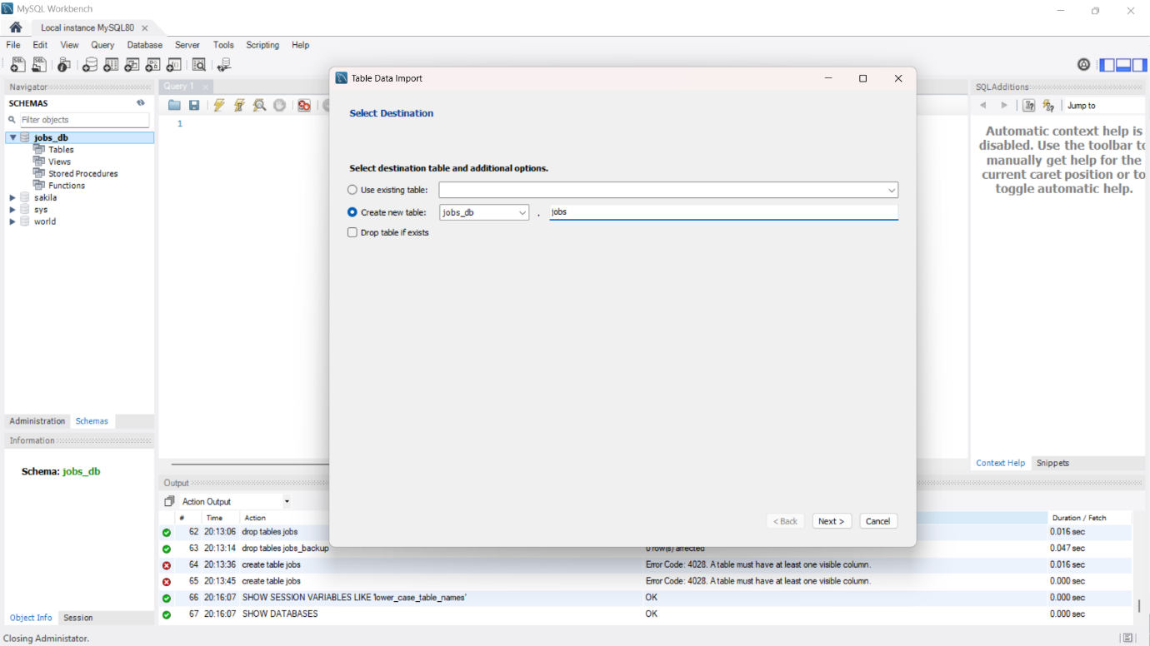

- Click next if you want to change the datatype you can do but we will change the datatype later with query.
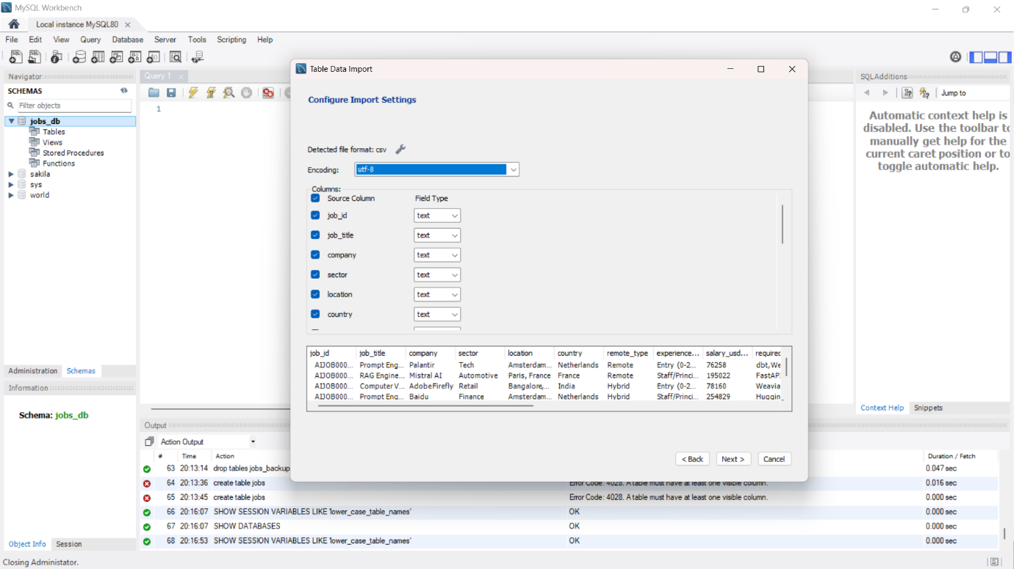

- Click next to start importing the files in the workbench.
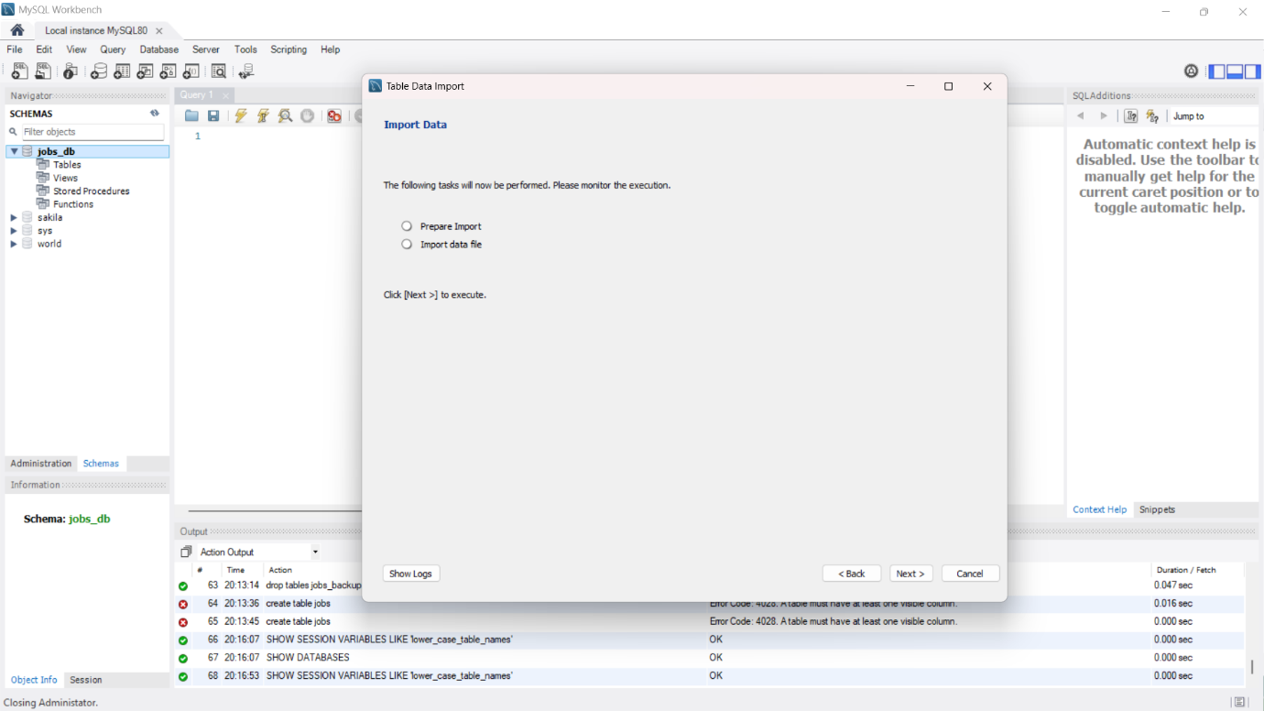

- Click Next as the file import is done.
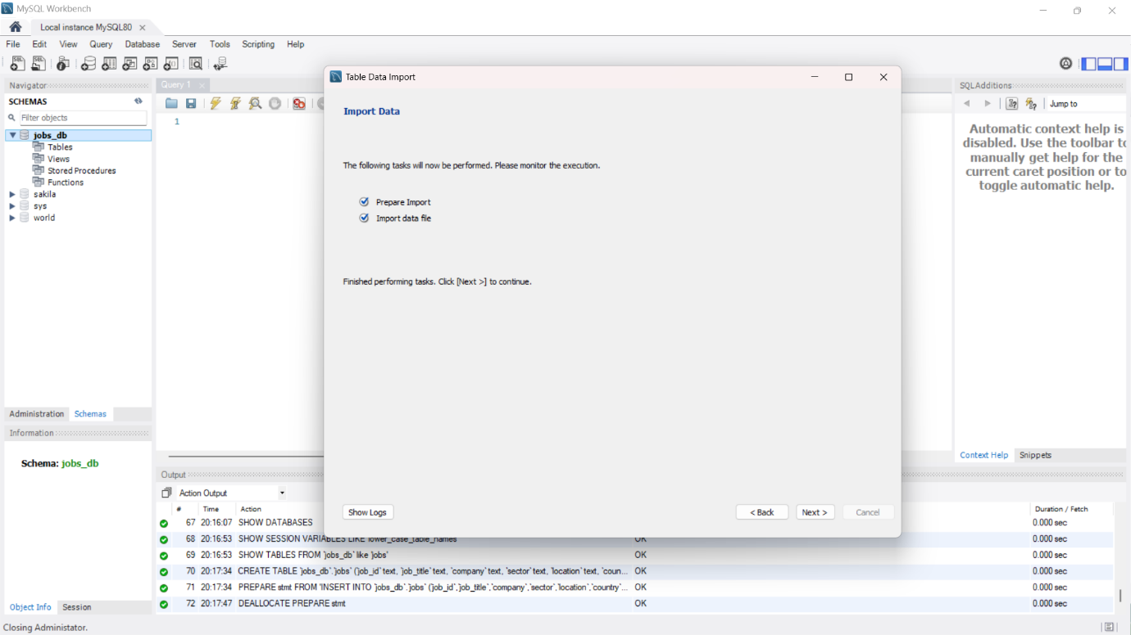

- Click finish as it shows that a table with name ‘jobs’ is created and 2500 records were imported.
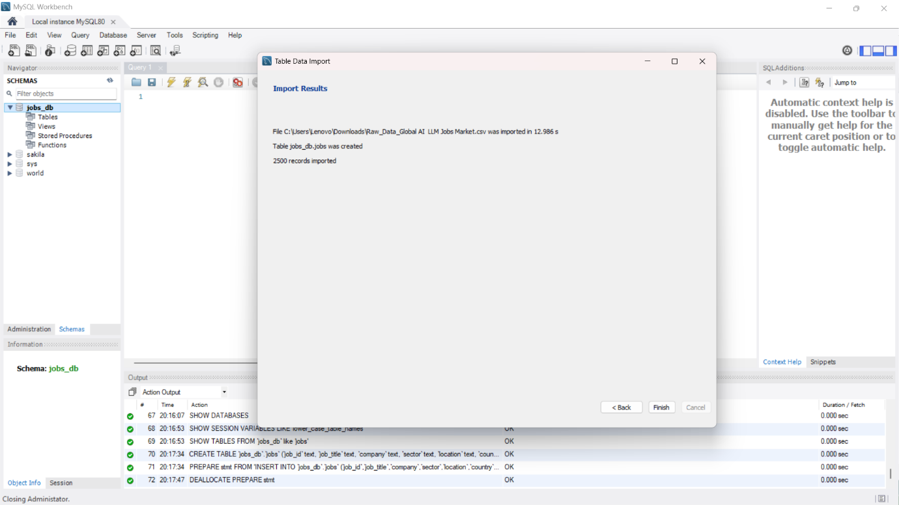

- Create a backup of the table for a safety.
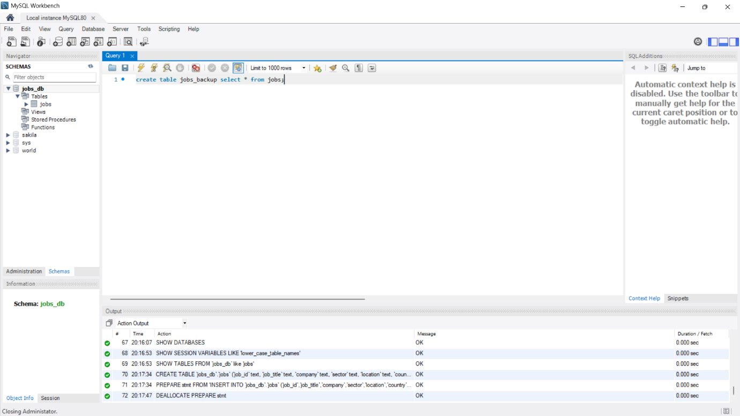

- To find missing value in MySQL
select
sum(job_id is null or job_id='') as missing_job_id,
sum(job_title is null or job_title='') as missing_job_tittle,
sum(company is null or company='') as missing_company,
sum(sector is null or sector='') as missing_sector,
sum(location is null or location='') as missing_location,
sum(country is null or country='') as missing_country,
sum(remote_type is null or remote_type='') as missing_remote_type,
sum(experience_level is null or experience_level ='') as missing_experience_level,
sum(salary_usd_annual is null or salary_usd_annual ='') as missing_salary_usd_annual,
sum(required_skills is null or required_skills='') as missing_required_skills,
sum(primary_llm_mentioned is null or primary_llm_mentioned = '') as missing_primary_llm_mentioned,
sum(education_required is null or education_required='') as missing_education_required,
sum(applies_count is null or applies_count='') as missing_applies_count,
sum(visa_sponsorship is null or visa_sponsorship='') as missing_visa_sponsorship,
sum(years_experience_min is null or years_experience_min='') as missing_years_experience_min,
sum(company_size is null or company_size='') as missing_company_size,
sum(is_contract is null or is_contract='') as missing_is_contract,sum(has_equity is null or has_equity='') as missing_has_equity
from jobs;

- For Duplicate
select
job_id, job_title,company,sector, location, country, remote_type, experience_level, salary_usd_annual, required_skills, primary_llm_mentioned, education_required,
count(*) as duplicate_count
from jobs
group by job_id, job_title, company, sector, location, country, remote_type, experience_level, salary_usd_annual, required_skills,primary_llm_mentioned, education_required
having count(*) > 1;

- 'TX','IL','NY','CA','WA' change to United States and ‘UK’ to United Kingdom
SET SQL_SAFE_UPDATES = 0;
update jobs
set country = 'United States'
where country in ('TX','IL','NY','CA','WA');
SET SQL_SAFE_UPDATES = 1;

SET SQL_SAFE_UPDATES = 0;
update jobs
set country = 'United Kingdom'
where country = 'UK';
SET SQL_SAFE_UPDATES = 1;

Check all distinct type
select distinct country
from jobs
order by country;

- Tech to Technology
SET SQL_SAFE_UPDATES = 0;
update jobs
set sector = ‘Technology’
where country =’Tech’;
SET SQL_SAFE_UPDATES = 1;

- Str to Date
SET SQL_SAFE_UPDATES = 0;
update jobs
set date_posted= str_to_date(date_posted,'%Y-%m-%d');
SET SQL_SAFE_UPDATES = 1;
alter table jobs
modify column date_posted date;

- Modifying salary from int to decimal
alter table jobs
modify column salary_usd_annual decimal(12,2);

- Splitting the experience level
alter table jobs
add column experience_years varchar(10);

SET SQL_SAFE_UPDATES = 0;
update jobs
set experience_years=case
when experience_level like 'Entry%' then '0-2'
when experience_level like 'Mid%' then '2-5'
when experience_level like 'Senior%' then '5-8'
when experience_level like 'Staff/Principal%' then '8+'
else null
end;
SET SQL_SAFE_UPDATES = 1;

SET SQL_SAFE_UPDATES = 0;
update jobs
set experience_level=case
when experience_level like 'Entry%' then 'Entry'
when experience_level like 'Mid%' then 'Mid'
when experience_level like 'Senior%' then 'Senior'
when experience_level like 'Staff/Principal%' then 'Staff/Principal'
else null
end;
SET SQL_SAFE_UPDATES = 1;

- Fixing the company size
SET SQL_SAFE_UPDATES = 0;
update jobs
set company_size='1-50'
where company_size='Jan-50';
SET SQL_SAFE_UPDATES = 1;

- None llm fixed & changing data type
SET SQL_SAFE_UPDATES = 0;
update jobs
set primary_llm_mentioned='No_LLM_Required'
where company_size='None';
SET SQL_SAFE_UPDATES = 1;

alter table jobs
add column primary_llm_clean varchar(25);

- Dropping field (job_description_length not required)
alter table jobs
drop column job_description_length;

- To change data type
alter table jobs
modify job_id varchar(15),
modify job_title varchar(50),
modify company varchar(25),
modify sector varchar(15),
modify country varchar(50),
modify remote_type varchar(15),
modify experience_level varchar(15),
modify salary_usd_annual decimal(12,2),
modify required_skills text,
modify primary_llm_mentioned varchar(25),
modify education_required varchar(25),
modify date_posted date,
modify applies_count int,
modify visa_sponsorship varchar(10),
modify years_experience_min int,
modify company_size varchar(30),
modify is_contract varchar(15),
modify has_equity varchar(5),
modify experience_years varchar(5);

- Add Primary key
alter table jobs
add primary key(job_id);

